分类号： H315.6 单位代码： 10636
密 级： 公开 学 号： J200906009


专业学位硕士论文

中文论文题目 ：课外自主阅读对高一英语阅读的
辅助性研究
英文论文题目： The Assistant Role of Autonomously
Extensive Reading in Senior One English Learning
论文作者： 张 谦
指导教师： 尹 世 寅
专业学位类别： 教 育 硕 士
专业领域： 学 科 教 学（英 语）
论文形式： 英 语
所在学院： 外国语学院
论文提交日期： 2013 年 3 月 1 日
论文答辩日期： 2013 年 5 月 23 日
四川师范大学学位论文独创性声明

本人声明：所呈交学位论文《课外自主阅读对高一英语阅读的辅助性研究》The Assistant Role of Autonomously Extensive Reading in Senior One English Learning，是本人在导师 尹世寅 指导下，独立进行研究工作所取得的成果。除文中已经注明引用的内容外，本论文不含任何其他个人或集体已经发表或撰写过的作品或成果。对本文的研究做出重要贡献的个人和集体，均已在文中以明确方式标明。本声明的法律结果由本人承担。
本人承诺：已提交的学位论文电子版与论文纸本的内容一致。如因不符而引起的学术声誉上的损失由本人自负。

学位论文作者： 签字日期： 年 月 日

四川师范大学学位论文版权使用授权书

本人同意所撰写学位论文的使用授权遵照学校的管理规定：
学校作为申请学位的条件之一，学位论文著作权拥有者须授权所在大学拥有学位论文的部分使用权，即：1）已获学位的研究生必须按学校规定提交印刷版和电子版学位论文，可以将学位论文的全部或部分内容编入有关数据库供检索；2）为教学、科研和学术交流目的，学校可以将公开的学位论文或解密后的学位论文作为资料在图书馆、资料室等场所或在有关网络上供阅读、浏览。

本人授权万方数据电子出版社将本学位论文收录到《中国学位论文全文数据库》，并通过网络向社会公众提供信息服务。同意按相关规定享受相关权益。
（保密的学位论文在解密后适用本授权书）

学位论文作者签名： 导师签名：

签字日期： 年 月 日 签字日期： 年 月 日

课外自主阅读对高一英语阅读的辅助性研究

学科教学（英语）

硕士研究生：张谦 指导教师：尹世寅

摘要 国家教育部2003年颁布的《普通高中英语课程标准》（下称《标准》）指明我们的教学应该“以人为本”关注学生本质上的发展，并在此过程中培养学生的自主学习能力（《标准》，1），从而帮助他们成为一位终生学习者和一位合格的世界公民。《学习：财富蕴藏其中》(Jacques Delors, 1996)，阐明了21世纪教育的4大支柱：“学会学习，学会实践，学会共存和学会与他人相处” (McDeitt, 1997:34)。它也指出了教育的终极目标是实现学生在课堂内外的社会化，把学生培养成为对社会有用的人。同时，社会的发展也要求所有的人要成为终生的学习者。从以上的要求来看，培养学生的自主学习能力成为一种必要。
自从20世纪八十年代起，许多国内外的研究者就开始关注自主学习并指出能够应用自主学习及其优势的学生在英语学习上更有优势。这些学生对于英语学习材料有更深的理解和更高的英语学习效率从而在面对英语学习时有更积极的自我评价和更大的热情。显然，在中国高中阶段的英语教学中广泛推广学生自主学习是很有价值的。
尽管如此，现实中的英语阅读教学不能满足《标准》的要求和学生英语学习的发展，更不要说帮助学生成为合格的终生学习者和世界公民了。因此，基于对高效英语学习和实际低效的高一英语课堂之间的差距，本研究主要研究课外自主阅读对高一英语阅读的辅助性研究，并试图通过找到将填鸭式的知识为基础的传统教育方式转变为以学生为中心的，学生主动去探知知识的有趣的体验过程，来提高高一学生在英语阅读过程中的表现。本研究也希望通过对高一学生英语课外自主阅读能力的培养，为他们未来两年的高中学习乃至将来的终身学习打下基础，也为他们成为合格的终生学习者和世界公民打下基础。
在实验阶段，作者做了大量的实验来证明课外自主阅读对高一英语阅读的辅助性。这些实验主要是关于怎样在实验班级进行AER训练，比如如何扩大学生的词汇量，强化对学生的阅读技巧指导，整合学生的课外阅读资源、帮助学生制定一个适合自己的阅读计划表，并进行实时的检测和过程性评价。希望本研究能为所有有志于帮助自己的学生成为合格的终生学习者和世界公民的老师们提供一些实际可操作的方式。
关键词：辅助性 课外自主阅读 高一 英语阅读

The Assistant Role of Autonomously Extensive Reading in Senior

One English Learning

Abstract

MA Candidate: Zhang Qian Advisor: Yin Shiyin

National English Curriculum Standards for Senior Middle Schools issued by the Ministry of Education in 2003 demonstrate the education during this period of time should focus on students’ entity and promote students’ learning ability in order to help them become a lifelong learner and a qualified global citizen. Learning: the Treasure Within (Jacques Delors, 1996) formulated the four pillars of education: “learning to know, learning to do, learning to live together, learning to live with others and learning to be” (McDeitt, 1997:34). It also declared that the ultimate goal of education is to reach the personal socialization of students both inside and outside the classroom. Meanwhile, with the development of society, it is required that all people should become lifelong learners. Therefore, it is critical to cultivate students’ autonomous learning ability.
Since 1980s, many researchers in China and abroad have emphasized on the autonomous learning and claimed that the students who can apply autonomous learning strategies have a more positive attitude toward English learning, have a deeper understanding of the learning materials and higher English proficiency which result in more active self-assessment and greater passion of English learning. Apparently, it’s worth promoting the wide application of autonomous learning in English-teaching in Senior High schools in China, especially the assistant role of autonomous learning on extensive reading in Grade one, Senior High.
While the practical English reading, teaching and learning can’t reach the requirement of National English Curriculum Standards for Senior Middle Schools and the need of students’ English learning development, to say nothing of helping students become lifelong learners？. Therefore, this study focuses on study the practical approaches in order to develop students’ own autonomously extensive reading (AER) ability with the assistance and guidance of teachers , aiming to find the efficient approaches to transform the passive and knowledge-based teaching method of English reading to a more meta-cognitive, interesting process and autonomously learning experience for students.
During the experimental period, the author did the first-handed experiments to prove the assistant role of autonomously extensive reading in Senior One English learning. These experiments are concerned with AER training in the experimental class, including enlarging students’ vocabulary, enriching their background knowledge for English, stimulating students’ motivation and interest in AER, strengthening the instruction of reading strategies, integrating AER resources and helping students make a proper schedule, monitor it and assess the process. By doing so, the author did prove that autonomously extensive reading has an assistant role of in Senior One English learning. Hopefully, this study can provide some practical ways to all the teachers interested in helping their students become lifelong learners and qualified global citizens.

Key words: the assistant role, autonomously extensive reading, Senior One English Reading

Contents
中文摘要 I
ABSTRACT III
Introduction 1
Chapter One Research Background 4
1.1. General situation of English reading in Senior One 4
1.2. Demands of National English Curriculum Standards for Senior One 7
1.3. Necessity and importance of autonomously extensive reading (AER) in Senior One 8
Chapter Two Literature Review and Theoretical Support 9
2.1. Theories on reading 9
2.2. Theories on autonomous learning 12
2.3. Studies on autonomously extensive learning at home and abroad 18
Chapter Three Methodology 22
3.1. Approaches used in this experiment 22
3.2. Objects and Subjects 22
3.3. Instruments 23
3.4. Procedures 24
Chapter Four Data Analysis and Major Findings 27
4.1. Data Analysis of the experiment 27
4.2. Major findings 51
Chapter Five Pedagogical Implications, Limitations and Suggestions 52
5.1. Pedagogical Implications 52
5.2. Suggestions 55
Conclusion 56
Bibliography 57
Acknowledgements 59
Appendices 60

Introduction

National English Curriculum Standards for Senior Middle Schools (2003) issued by the Ministry of Education in 2003 demonstrates that we should make the process of learning language become the process of forming the active emotional attitude, active thinking, brave practice, cross-cultural awareness and autonomous learning ability. The basic conception is to optimize students’ learning methods and improve their autonomous learning ability, thus helps the students develop autonomous and cooperative learning ability by means of observing, experiencing and exploratory learning. Teachers should teach students to establish their own learning methods and style by using multi-medias and various information resources and broaden their learning approaches. National English Curriculum Standards for Senior Middle Schools also emphasizes the important role of the students in classrooms and it is critical that senior high students should learn how to study, how to self-monitor and how to self-assess.
Learning: the Treasure Within (Jacques Delors, 1996), one of the reports to the Education, Scientific and Cultural Organization of the United Nations (UNESCO) of the International Commission on Education for the 21 Century, formulated the four pillars of education: “Learning to know, learning to do, learning to live together, learning to live with others and learning to be” (McDeitt, 1997:34). It also expounded that the ultimate goal of education is to reach the personal socialization of students both inside and outside the classroom. Meanwhile, with the development of society, it is required that all people should become lifelong learners. Therefore, teachers should pay attention to the roles of the students in the educational activities.
To fulfill the requirements above, autonomous learning should be of significant importance for the lifelong development of people. Firstly, most second language researchers believe that language is acquired as learners are actively involved in attempting to communicate using the target language, and acquisition of the language should be maximized when learners are engaged in the activities that force them to the limitation of their current competence. Secondly, autonomous learning will increase the chances for learners to use the language and promote a positive learning atmosphere, which significantly help promote the language learning and facilitate the language acquisition.
However, the traditional teacher-centered and knowledge-based teaching method is common in current English classrooms. In such a traditional classroom, the teacher dominates the input of grammar and knowledge throughout the teaching session while students simply sit, listen and take notes. As a result, students often feel overly passive and indifferent to what is being taught, which contribute to the decreasing motivation and enthusiasm of English learning, finally, leading to the low English proficiency.
To cultivate the students’ interest in English learning, since 1980s, many researchers have emphasized the autonomous learning, which was very popular in the field of applied linguistics. Numerous researchers in China and abroad (Sheerin 1991, Kenny 1993, Moore 1992, Booton and Benson 1996) who studied the autonomous learning and its benefits in an EFL classroom claimed that the students who can apply autonomous learning strategies have a more positive attitude to English learning, a deeper comprehension of the learning materials and higher English proficiency which result in a more active self-assessment and greater passion toward English learning. They have also emphasized the advantages of autonomous learning: creating a learner-centered EFL classroom, raising students’ motivation and interest, enhancing the ability of the extensive reading. Therefore, it’s worth promoting the wide application of autonomous learning in English-teaching in Senior High School in China. However, ,most previous researches mainly focus on the second or foreign language learning in general, few of them concentrate specifically on reading itself, especially the assistant role of autonomous learning on extensive reading in Senior High.
To bridge the gap between the high expectations of English-learning proficiency and the low practical traditional English-teaching classroom approaches, the study of my thesis characterizes the assistant role of autonomous learning on extensive reading in Senior High, aiming to find the efficient approaches to transform the passive and knowledge-based teaching of English-reading to a more meta-cognitive and interesting process and experience to students, which therefore improve students’ performance in English-learning in reading comprehension. Thus, students can taste the wonderful flavor of learning, build the confidence of being a lifelong learner and become a qualified global citizen.
This thesis consists of five chapters besides the introduction which includes the contents, purpose, meaning and framework of this thesis. Chapter One is the significance of this thesis, which formulates the general situation of English reading learning in Senior One and the demands of the National English Curriculum Standards for Senior One. Through the formulation, the necessity and importance of autonomous extensive reading (AER) in Senior One are revealed.
Chapter Two concentrates on the literature review and the theoretical basis on reading, and autonomous learning in China and abroad, such as their basic definitions, characteristics and practices including some rationales for autonomous reading: cognitive psychology, meta-cognition, constructivism and humanistic psychology.
Chapter Three deals with the methodology of this study based on the present situation of AER in senior one and proves the effect of expected AER strategies of the present study so that we can figure out efficient ways of cultivating students’ ability of AER. This chapter contains approaches used in this experiment, objects, subjects, instruments and procedures of the experiment.
Chapter Four involves data analysis and major findings. It proves the supplementary role of autonomous extensive reading on intensive reading in Senior One students by analyzing some experimental data.
Chapter Five focuses on the pedagogical implications, limitations and suggestions of the study. It is also concerned with AER training in the experimental class, such as enlarging students’ vocabulary, enriching their background knowledge for English, stimulating students’ motivation and interest in AER, strengthening the instruction of reading strategies, integrating AER resources and helping students make a proper schedule, monitor it and assess the process.
Finally, there is a conclusion, summarizing the main viewpoints of this thesis.

Chapter One

Research Background

In this chapter, the current general study of English reading learning will be analyzed and the significance of the study will be discussed.

1. 1 General situation of English reading learning in Senior One
With the internationalization of the world, the importance of mastering English is a well-known fact; many students are told to master English well, especially in Senior One for this period is the foundation for the rest two years. But can they learn English well in Senior One? Obviously, negative. As a Senior High English teacher working for ten years, the author has summarized the following general situation of English reading learning in Senior One.

1. 1. 1 Lack of autonomous learning ability caused by teacher-oriented teaching pattern
Reading is a core means of learning English in EFL Class in Senior High, not only because it’s one of the four basic language skills (Listening, Speaking, Reading and Writing)(Jiang Yunju 2006:1) but also because it’s one of the main channels for students to obtain language input and improve their linguistic competence. Whereas, English reading learning in Senior High is far from enough for a learner to be satisfied with English learning, especially in Senior One. With a heavy teaching task while so little teaching time, most English teachers concentrate on Reading in the textbooks and sink into teacher-oriented EFL Class. Teachers emphasize the discipline of their class so as to explain more new words and phrases in a new text, paraphrase more sentences and grammatical knowledge. In these traditional classes, the main task for students is to write down as many notes as possible and do some relative practice and drills. Under this teaching pattern, it’s no wonder that students form passive learning habits and lack of autonomous learning ability.

1. 1. 2 Obstacles to students’ English reading comprehension
As stated above, teacher-oriented teaching pattern is one of the obstacles to students’ English reading comprehension. Besides it, there are some other obstacles as follows:
Firstly, students are lack of enough vocabulary. Vocabulary is the foundation of English language learning. “Rather than viewing vocabulary item as a long and boring list of words, vocabulary is seen in its central role in contextualized, meaningful language.” (Brown. 365). Developing enough vocabulary is a priority for students in English reading learning in Senior One. A vocabulary of 1,500 words severely obstacles students reading autonomy because a vocabulary of at least 3,000 headwords is needed to read unsimplified texts with any ease (Nation 116). Otherwise, students can never read unsimplified texts including test papers, to say nothing of extensive reading and being in love with English reading.
Secondly, students are lack of background knowledge for English. Students usually feel confused facing materials containing background and cultural knowledge. Steffensen (1981) does an experiment on the influence of background knowledge about reading comprehension. In that experiment, there are two passages about weddings: one is about Indian wedding; the other is about North American wedding. Two groups of people from Indian and North American are asked to read those two passages. The result shows that both group have a better comprehension when comprehending the passage on their own background knowledge (Dong Yanping 102).
Thirdly, students are lack of motivation and interest in English extensive reading. With the heavy burden of the college entrance examination, most students are buried in various examination drills so that they can not dip into English extensive reading to feel the beauty of lines. Nuttall (129) presents that “the best way to master a foreign language is to read extensively the target language materials besides being in the language environment.” “Where there is little reading, there will be little language learning” (Bright & Mc Grogor 52, cf., LV ZhongShe 8), so if students have no motivation and interest in English extensive reading, how can they learn English well?
Fourthly, students are lack of proper reading strategies. Give a man a fish; you have fed him for today. Teach a man to fish; and you have fed him for a lifetime. That’s why teachers may as well give specific instructions of extensive reading rather than ask students just read passages again and again. Following is a table designed by teachers at Chinese University of Hong Kong (Bai Shumei 173), and it was used by the author in the author’s senior high school to discover the reading strategies used by students at the beginning of senior one while reading. The result is presented in Table 1.1.2
Table 1.1.2
No. | Reading strategies | Have always been used | Percentage (%)  (1656 in total)
1 | Possessing a purpose while reading. | 258 | 15.57
2 | Previewing the text to clear the topic and main idea. | 488 | 29.46
3 | Skimming for the general idea. | 692 | 41.78
4 | Scanning for the specific details. | 713 | 43.05
5 | Clustering words as a unit. | 435 | 26.26
6 | Abandoning dad reading habits. | 330 | 19.92
7 | Predicting what is to come. | 356 | 21.49
8 | Keeping asking and solving questions actively while reading. | 557 | 33.64
9 | Inferring ideas not stated directly in the text. | 423 | 25.54
10 | Identifying the framework of the text. | 406 | 24.52
11 | Identifying the structure of a paragraph. | 416 | 25.12
12 | Identifying sentence patterns in complex sentences. | 318 | 19.20
13 | Assigning cohesive pronouns and conjunctions. | 201 | 12.14
14 | Working out the meaning of new words in context. | 560 | 33.81
15 | Identifying figurative language and metaphors. | 236 | 14.25
16 | Understanding background knowledge. | 428 | 25.85
17 | Inferring the author’s purpose. | 369 | 22.28
18 | Tracking ideas by highlighting and note-taking. | 307 | 18.54
19 | Always reviewing what you’ve learnt. | 419 | 25.30
20 | Retelling the text in your own words. | 395 | 23.85
There is no difficulty drawing a conclusion that students in senior one have no conscience to use reading strategies when reading, while still there are two of them commonly used by students: Skimming and scanning.

1. 2 Demands of National English Curriculum Standards for Senior One
National English Curriculum Standards for Senior Middle Schools declares that the goal of senior English curriculum based on the goal of Level 1 to 5 in compulsory education has 4-level goals from level 6 to level 9. Level 7 is the requirement for a senior middle school graduate. Level 8 and 9 is the requirement for students who are fascinated with English and intend to learn about English in colleges. Since the thesis deals with English reading learning in Senior One, let’s focus more on Level 6. (National English Curriculum Standards)
About students’ autonomous learning ability, Level 6 emphasizes students to strengthen the motivation of learning and have a strong conscience for autonomous learning, such as making use of multiple educational resources and giving brief and simple assessments to their learning process and results, and adjusting their learning goals and strategies accordingly (National English Curriculum Standards, 2003).
On students’ reading ability and strategies, Level 6 also has the following requirements: students are capable to gain main information for general reading materials, to guess meanings of new words in context, to adjust their reading strategies according to different reading materials and to look for needed information with various approaches. Level 6 specifically put one more requirement on autonomously extensive reading: students should accumulate more than 180,000 words in autonomously extensive reading, which reveal the necessity and importance of autonomously extensive reading (AER) in Senior One.

1. 3 Necessity and importance of autonomously extensive reading (AER) in Senior One
Through the statements of general situation of English reading in Senior One and demands of National English Curriculum Standards for Senior One, it’s apparent that reading ability of students’ in Senior One is far from enough to the demands of National English Curriculum Standards for Senior One. How to fill in the gap? Cultivating students’ autonomously extensive reading attracts numerous English teachers’ attention. This is the actual calling for autonomously extensive reading (AER) in Senior One.
But most English teachers interested in AER usually cultivate students’ AER ability according to their experience not prove and summarize the strategies as this thesis, which tries to share some practical methods to help English teachers in Senior One to cultivate students’ AER ability thus lay a solid foundation for English learning in Senior high.
Besides, if students obtain AER ability in Senior One, on the one hand, they can learn English better by getting enough input in these three years in senior high, on the other hand, they can enquire the ability as a lifelong learner which can also help them in the long run. This is the necessity and importance of AER.

Chapter Two

Literature Review and Theoretical Support

With the significance discussed in Chapter One, the study needs some theoretical foundation which will be referred to in this chapter.

2. 1 Theories on reading
Reading is an indispensable cognitive activity in human society and is one of the primary means of human access to information and knowledge of the world around. Hence reading is an important part of English teaching. Over the years, scholars have given a great deal of concern to the study of the theory of reading. From the 60s of the last century, many scholars have proposed a series of reading models. A lot of reading theories have been formed. They have put forward different views on the definition and the process of reading.

2. 1. 1 Definition of reading
Definition on reading of Gibson and Levin (35) is considered to be comprehensive and accepted by many people. They think: “Reading is the process of extracting meaning from the articles” and the following needs to be done for extracting meaning from the articles: (1). Encode writing symbol into sound; 2. Get a corresponding writing symbol to obtain the meaning of written word from semantic memory. 3. Be able to integrate the meanings of these words. (Zhang Biyin, 25)
Definition of reading is divided into two classes by Downing and Leong (82): one emphasizes on the process of encoding and the other stresses on the obtaining of significance. In studying psychology of reading, the domestic scholar Zhang Biyin further modified the definition of reading as: reading is the process to obtain information from written materials and influence nonintellectual factor of readers. (Zhang Biyin, 3)
Psychologist of reading defines reading mainly from the process of reading, while language educators are mainly from the point of view of teaching and reading comprehension. Anderson (21) holds “Reading is an active, fluent process which involves the reader and the reading material in meaning. Meaning does not reside on the printed page, noris it only in the heado the reader.” Anderson believes that reading is the process of combining words on the book and the reader's background knowledge and experience.
William Grabe and Fredricka L. Stoller (29) thinks that it is not enough to define reading through simply a sentence (such as “Reading is the ability to draw meaning from the printed page and interpret this information appropriately.”). They explained reading and reading comprehension from four aspects of the purpose of reading, the process of defining, component involved in the process of reading and model of reading.

2. 1. 2 Purpose of reading
As we all know, reading is one of the most important input means in language learning. It helps the reader to move closer from the native language to the learning language, accumulate and ultimately achieve the purpose of output. Since reading is an individual, often silent activity, the teachers need to come to understand the type of reading and reading level of students, help students to adjust so as to read in an effective reading method for improving.
Reading usually has the following purposes:
1. Reading for Relaxation and Pleasure
2. Reading for Locating Specific Information
3. Reading for Practical Application
4. Reading for Improving Ability of Critical Thought
5. Reading for Acquiring Knowledge and Improving the Cultural Heritage
(Dai Yueyun 22)

2. 1. 3 Process of reading
Depending on different reading purposes and stages, we can choose different reading model. It can be said that reading model plays a role in insight and practice of our teaching of English reading. There have been three reading models in the teaching of reading, i.e. Bottom-up Model, Top-down Model and Interactive Reading Model (Li Yuhua 15).

2. 1. 3. 1 The bottom-up model
In the 1960s, affected by behavioral psychology, reading process is seen as a passive “bottom-up” process. A linguistician, Gough was the first to propose this theory. According to this theory, reading is only regarded as the process of reacting on the linguistic symbol. The purpose of reading is only limited to the identification and confirmation of these language symbols, from the identification of letters, words to sentences, paragraphs, till the meaning of the article is naturally acquired. Caroll (1964) described the reading process at that time as: “Reading is carries out along the one-way procedure of ‘visual stimulation→ oral re-encoding→ responding literally’.” However, the reading process seems too simplistic in this reading model, and cultural and background significance carried is ignored. To modify the defect of the bottom-up model, the top-down model emerges as the times requires.

2. 1. 3. 2 The top-down model
The top-down model was put forward by K. S. Goodman and F. Smith in late 1960s and early 1970s. In this mode, the readers were regarded as active participant instead of passive receiver. In the process of reading, the readers forecast, assume, test and verify the content of articles to acquire the significance from the knowledge in their own brain, i.e. a process of guessing－confirming. Readers no longer need to accurately identify each word in each sentence, but select useful information according to their original language information and cultural background knowledge, they conjecture and predict while testifying and modifying in order to understand correctly. Language structure knowledge in the reader's mind, psychological factors and background knowledge is the basis of reading, which has also become important factors affecting reading. Although this model has solved the problem of the bottom-up model, the role of conjecture is overemphasized, which will lead to the assumption phenomenon (Li Yuhua 23).

2. 1. 3. 3 The interactive model
In 1977, artificial intelligence scientist, D.G.Rumelhart created the interactive model of reading on the basis of learning from the artificial intelligence theory through large number of studies. He pointed out that one the one hand that reading was the process of processing language, while on the other hand that reading is the process in which readers used and handled the known background knowledge, it was the result of interaction of bottom-up model and top-down model (Wang Xiuxiang 20).
The bottom-up model can be used in the stage of wiping out reading disorder of students, while top-down model is for reading difficult reading materials, the interactive model for understanding and appreciating the article.

2. 2 Theories on autonomous learning
In this part, features of autonomous learning will be discussed, such as the definition and characteristics of autonomous learning.

2. 2. 1 Definition of autonomous learning
Independent learning is a modern learning manner that corresponds with the traditional reception learning. It takes students as subject of learning, achieving the learning objectives through independent analysis, exploration, practice, questioning, creation and other method of students (Wang Xiuxiang 4).

2. 2. 2 Characteristics of autonomous learning
For the characteristics of independent learning, Holmes & Ramos (1991) and Wenden (1998) divided autonomous learning into a number of characteristics. Gather up the threads, there are three characteristics of “self-reliance”, “self-doing” and “self-discipline” which constitute three pillars of the “autonomous learning” and the basic characteristics shown.
Independence
(1) Each learning subject is people with relative independence. Learning is the matters concerning to the learning subject “itself” and behavior of itself, irreplaceable.
(2) Each learning subject has self-independent psychological cognitive system, insight into their own learning methods and learning strategies.
(3) Each learning subject has desire for seeking independence which is the inner basis and power for acquiring independence.
(4) Each learning subject has “heaven-born” learning potential and certain stand-alone capability. They rely on their own to solve the “obstacles” in the learning process thus acquiring knowledge (Huang Shan 34~35).
“Autonomous learning” is learning subject learns by self-reliance, self-doing and self-discipline which are reflections in three aspects and three basic characteristics of autonomous learning. Among them, self-reliance is the foundation of autonomous learning, self-doing is its essence while self-discipline is its guarantee. These three characteristics are of the same thought: the learning subject is master of self-learning, and learning is led and completed by the learning subject itself in the final analysis (Zhang Xiangyang 27).

2. 2. 3 Rationales for autonomous learning
The rationales for autonomous learning are made up of four theories: cognitive psychology, meta-cognition, constructivism and humanistic psychology. The details will be explained as follows.

2. 2. 3. 1 Cognitive psychology
Cognitive psychology is a thought of psychology rising in the West in the mid-1950s. It is the psychological mechanism as the basis of human behavior. Its core is the internal psychological process that occurs between the input and the output. It also linked with traditional Western philosophy; mainly featuring emphasis on the role of knowledge for knowledge is the determinants of human behavior (Liang Xiaoju 13).
In a broad sense, cognitive psychology contains constructionism cognitive psychology represented by Piaget, psychologism psychology and information processing psychology. In a narrow sense, cognitive psychology is information processing psychology. It uses information processing and other views of point to study the cognitive process of human to receiving, storing and applying information, including research on perception, attention, memory, mental imagery (i.e. representation), thinking and language. The main research methods are experiment, observation and computer simulation (Liang Xiaoju 14).
Major representatives of cognitive psychology are American psychologist and computer scientist Alan Newell (1927) and American scientist, one of the pioneers of artificial intelligence, Herbert Alexander Simon (1916), etc. Their main theoretical perspectives are:
1. The human brain is regarded as a computer-like information processing system
2. Knowledge and knowledge structure of the human mind have decisive role in human behavior and awareness activities
3. Integrity of the cognitive processes
4. Production system

2. 2. 3. 2 Meta-cognition
The word “Meta-cognition” was firstly appeared in the book - Cognitive Development written by US child psychologist, J. H. Flavell in 1976. Meta-cognition is the cognition to cognition. To be specific, it is the knowledge about one’s own cognition process and the ability to adjust these processed: knowledge and control to thinking and learning activities. Meta-cognition includes meta-cognitive knowledge and meta-cognitive control. For example: “learn how to learn” which is often in instructional psychology refers exactly to such cognition. The essence of the meta-cognition is self-awareness and self-regulation to the cognitive activity (Wang Xingyuan 16).
Meta-cognitive knowledge is knowledge about cognition, i.e. the understanding of people on what factors affect a person’s cognitive activities and results, how these factors work, how they interact and other problems. The meta-cognitive knowledge mainly includes the following three aspects:
(1) The knowledge about the individual as the learner, i.e. the knowledge on all characteristics of people as cognitive processor who is learning or thinking.
(2) The knowledge of the task, in the aspect related to cognitive material, the subject shall be realized that the nature, length, familiarity, structural characteristics, presentation, logicality of the material and other factor will affect proceeding and result of our cognitive activities; in aspects related to cognitive goals, tasks, whether the subject knows that goals and tasks of different cognitive activities may differ, some cognitive activities may have more, higher and more difficult requirements.
(3) Knowledge about learning strategies and their uses(Wang Xingyuan 19~22).

2. 2. 3. 3 Constructivism
As to constructivism, the first presenter could track back to J.Piaget from Switzerland. He was a psychologist with greatest influence in cognitive development field, and the school he established concerning cognitive development of children was called by people Geneva school. J. Piaget’s theories were full of materialistic dialectics, and he persisted in studying cognitive development of children from the opinion of interaction of internal cause and external cause. He thought that children gradually established the cognition related to the outer world during the interaction with ambient environment, thus making their own cognitive structures develop (Huang Shan 26).
Learning view of constructivism
(1) Learning is not the process that the teacher simply transmits knowledge to students but students themselves construct knowledge. The students do not simply and passively receive information but actively construct knowledge significance, and such construction cannot be replaced by others.
(2) Learning is not passively receiving information stimulation but actively constructing significance, and it is that actively select and process external information according to one’s own experience background thus receiving his significance. External information itself is of no significance, and significance is constructed by learners through the repeated and two-way interaction between new and old knowledge and experience. Therefore, learning is not like the “stimulation? reaction” described by behaviorism.
(3) Receiving of learning significance refers to that each learner re-understands and re-encodes the new information to construct his understanding based on his original knowledge experience. During the process, the original knowledge experience of the learner is adjusted and changed because of access of new knowledge experience.
(4) Assimilation and adjustment are two means or ways by which the cognitive structures of learners change. Assimilation is the quantitative change of cognitive structure, while adjustment is the qualitative change of cognitive structure. Assimilation — adjustment — assimilation — adjustment … move in circles, balance — imbalance — balance — imbalance alternate, and the development of cognitive level of people is such process. Learning is not simple information accumulation, what’s more important is that it includes the conflict between new and old knowledge experience, and the reconstruction of cognitive structure incurred by this. Learning process is not simple information input, storage and extract, but the two-way interaction between new and old knowledge experience, i.e. the interactive process between learners and learning environment (Huang Shan 26~28).

2. 2. 3. 4 Humanistic psychology
Humanism emerged in America in 1950s-1960s, and rapidly developed in 1970s-1980s, it not only objected to behaviorism equating human to animal to only study human’s behaviors but not understand human’s internal nature, but also criticized that Freud only studied neurosis and mental patients but not investigated mentality of normal person, thus it was called the third movement of psychology.
Humanistic school emphasizes dignity, value, creativity and self-actualization of human and resolves self-actualization of human nature into realization of potentiality, and the potentiality is a nature similar to instinct. The greatest contribution of humanism is seeing the conformance of human mentality and human essence, and proposing that psychology must set out to study human mind from human nature (Zhang Xiangyang 21).
Main representatives of the school were Abraham Maslow and Carl Rogers. Main opinions of Maslow included: studied and classified human’s basic needs, and distinguished it from animal instinct, proposed that human needs are developed by layers; he arranged various needs of human in a hierarchical sequence system from low to high according to the differences of pursuing goals and meeting objects, and the lowest need is physiological need, and this is the need which people feel needs to be prior met. Rogers (118) thought, life is a process making individual constantly grow up and reach perfection, and the process is the control of tendency realization and control pointing to individual growth and autonomous removal of external power. During the process, environment (including educational factor) plays a significant role. Individual has always developed self-awareness on the basis of receiving unconditional positive affirmation and positive self-affirmation. On that basis, Rogers proposed learning view and teaching view of “free learning” and “student center” with the aim of cultivating person integrating “body, noema, emotion, spirit and thought together” through well-informed and uniform way, i.e. whole person. The education can “promote change and learning, cultivate person being able to adapt to changes and knowing how to learn.” Three basic principles of cultivating psychological climate are sincerity or reality, esteem, attention and acceptance, empathic understanding. The greatest inspiration of the basic teaching view of Rogers on preschool education is: treat a child as a person needing esteem, breathe with the child together, and grow up with the child. The primary work of the teacher is not teaching but promotion, and he shall build life atmosphere for significant learning. In the meantime, teacher himself is resource, and he shall share emotion and communicate thought with children; teachers shall escape from busy teaching plan writing as much as possible but provide various resources to meet individual needs of children (Zhang Xiangyang 25~28).

2. 3 Studies on autonomous learning at home and abroad
Autonomous learning is not a new conception. A lot of researchers and experts have been studying it for a long time at home and abroad.

2. 3. 1 Studies on autonomous learning abroad
The thought of autonomous learning has been of long standing. After Socrates, Plato and Aristotle from ancient Greek, Rousseau, Diesterweg and Dewey etc. are the pioneers of the thought of autonomous learning. Since 1950s, autonomous learning has become the important subject of educational psychology study. In the book Autonomous Learning and Learning: Theory, Study and Practice published in late 1980s, some discussions made concerning autonomous learning from Vygotsky school, operationism, phenomenological school, sociological school, will theory and information processing psychology etc. different points of view were systematically summarized (Wang Xiuxiang 45). However, because of the differences of theory standpoints and angles of view of researchers, there has not been uniform view yet concerning what is autonomous learning. Currently, there are many terms related to autonomous learning used in foreign countries, such as self-regulated learning, self-managed learning, active-learning, autonous learning, self-planned learning, self-monitored learning, self-directed learning, self-education and self-instruction etc. In foreign countries, the thought of autonomous learning has always been paid attention to by psychology and education. However, the mid-1900s later, as information processing theory psychology has rapidly developed, language self-instruction theory of Vygotsky received recognition in western countries, rising of humanism psychology and the development of psychological fields have promoted the theory elaboration or practice study on autonomous learning from different angles (Wang Xiuxiang 47).

2. 3. 2 Studies on autonomous learning in China
In our country, the thought of autonomous learning started earlier, and it emphasized that knowledge learnt shall be obtained through one’s own thought. The point has been reflected in thoughts of many educators. For instance, Mencious insisted that learning must be obtained through one’s own assiduous study, then one could be enlightened in the deep heart, thus reaching pleasant state, and when applying to practice in future, the success might be achieved one way or another, i.e. so-called “people following certain methods to reach intensive attainments is to learn something, thus firmly grasping that for deep accumulation, and with deep accumulation, when applying, one is able to achieve success one way or another. Therefore, what people wish is to gain something.” (Mencious). Xuncius also required the students to actively attend school and set out from “soul-searching”, i.e. so-called “ancient people learn to satisfy themselves, while people today learn to satisfy others.” (Xuncius 38). He thought that as to people’s learning, “that what has been learnt shall be heard in the ear, reminded in the heart, distributed to arms and legs, and expressed in every movement”. (Xuncius 39), it shows that learners must think by themselves and put into practice.
The systematic study on autonomous learning in our country started in 1980s. Many scholars made researches and did experiments in some places, and also got some achievements. Before and after 1979, there were many teaching experiments with the goal of instructing students for autonomous learning appearing, such as: “reading, discussing, practicing and speaking” eight-character teaching approaches summarized by Duan Peili etc. in Shanghai Yucai High School; “self-study guidance teaching” experiment study hosted by Lu Zhongheng in Institute of Psychology, Chinese Academy of Sciences; “six-step teaching approach” experiment implemented by Wei Shusheng in Liaoning Panjin No.2 Middle School; “guided teaching approach” study conducted by Qian Menglong in Shanghai Jiading Middle School, etc. All these teaching experiments take “autonomous learning” as the main link of teaching, and clearly take the cultivation of autonomous learning abilities of students and development of student intelligence as main pursuing goals (Wang Xingyuan 32~34).
1990s later, with the further development of educational reform in our country, especially with the gradual establishment and perfection of subjectivity education theory, the significance of autonomous learning received wide attention by educational theory circle and practice circle, and on the basis of inheriting the thought of autonomous learning in ancient China and using foreign autonomous learning theory for reference, the concept of autonomous learning was definitely proposed, and also autonomous learning was studied deeply and systematically, in theory circle, there are following several understandings on the concept of autonomous learning:
Such as Lu Zhongheng’s Self-study Guidance Psychology, Qiu Xuehua’s Attempt Teaching Method, Li Jingrao and Han Shupei’s Guided Teaching System. Dong Qi and Zhou Yong think that, autonomous learning can be divided into three aspects: the first is the advance planning and arrangement of one’s own learning activities; the second is the monitoring, evaluation and feedback of one’s own actual learning activities; the third is adjustment, correction and control of one’s own learning activities. Autonomous learning has the features of initiative, feedback, adjustment, migration and effectiveness, etc (Wang Xinyang 44~46).
Pang Guowei (132) defines autonomous learning from horizontal and longitudinal points of view. From horizontal point of view it refers to that autonomous learning is comprehensively defined from each aspect or latitude of learning. While defining autonomous learning from longitudinal point of view it refers to expounding the essence of autonomous learning from the whole process of learning. In addition, he also summarizes the autonomous learning as: “ability to learning” established on the basis of self-awareness development; “willingness to learning” established on the basis of students having intrinsic learning motivation; “skillful learning” established on the basis of students mastering certain learning strategies; and “persistence in learning” established on the basis of will effort. In the new period autonomous learning is given with new meaning, the autonomous learning way advocated by new courses is not only a learning ability, but a learning habit, learning quality and learning will.
In practice circle, Pei Dina etc. in Beijing Normal University hosted study on learning subjectivity, Wang Yong etc. in Fujian Province developed study on guidance —— autonomous learning, Dong Qi etc. developed psychology study of autonomous learning, Pang Guowei conducted study on the guidance mode of autonomous learning of middle school students. From September 2000 to April 2003, Yiwu Xiuhu Junior Middle Scholl of Zhejiang Province conducted study on classroom teaching guiding strategy comprehensively for all courses based on autonomous learning.
The person who has conducted systematic and comprehensive discussion on all important issues concerning autonomous learning is Pang Guowei from East China Normal University, and it is mainly reflected in his monograph —— Autonomous Learning — Theory and Strategy of Learning and Teaching (207). In the book the mental mechanism problems for autonomous learning, autonomous learning strategies and autonomous learning ability development etc. are discussed. He proposes the opinion of cooperative learning being collective autonomous learning, concreteness of the zone of proximal development and general mode for autonomous learning teaching guide, and provides special test tool for autonomous learning. He thinks that the study on autonomous learning can be developed through theoretical, experiment, test, observation and action studies.

Chapter Three

Methodology

This chapter focuses on the methodology of the study which contains approaches used in the experiment, objects, subjects, instruments and procedures.

3. 1 Approaches used in this experiment
This experiment is based on theories mentioned in chapter two: cognitive psychology, meta-cognition, constructivism, and humanistic psychology. To accomplish the study perfectly, the author also used questionnaires, interviews and three tests in the experiment which will be explained more in the following “Instruments” part.

3. 2 Objects and Subjects
Objects:
This study aims to solve three core questions:
- What’s the present general situation of AER in Senior One?
- Can AER enhance students’ reading competence in Senior One?
- If the second question is positive, what methods can be used to improve students’ AER ability?
The experiment mentioned in this chapter aims to testify a hypothesis: ARE can improve students’ reading competence which is also the second core question of the study. Furthermore, this experiment attempts to prove and share some practical methods of cultivating students’ AER ability in Senior One which can also collect some experimental figures for the third core question.
Subjects:
The subjects are 124 students in two natural classes from No.12 Middle School of Chengdu. Class 1 is the control class (CC), containing 64 students while Class 13 is the experimental class (EC), containing 60 students. Of the 124 students, 24 (37.5%) were males and 40 (63.5%) were females in the control class, while in the experimental class, 20 (33.33%) were males and 40 (66.67%) were females. Both two classes are the A-level students in No.12 Middle School of Chengdu, which has a over-100-year history and is ranked No.5 in Chengdu when it comes to the ratio of students received by colleges and universities in every year’s college entrance examination. The two classes are taught by the same teacher, using the same textbook, and have the same class hours (5 class hours per week). To make sure the validity and reliability of the experiment, AER training is carried out in the experimental class (Class 13) and the traditional way is applied in the control class (Class 1). Besides, the students were not informed of the experiment.

3. 3 Instruments
Instruments used in the experiment are questionnaires, interviews and three tests.
There were three questionnaires. The first one (Appendix I ) was used to get a present general situation of students at the beginning of senior one while reading in English reading. It is involved with 6 parts: reader’s motivation for AER (questions 1~10), reading goals and schedule (questions 11~19), reading strategies and habits (questions 20 ~40), reading results (questions 41~49), the choices of reading materials (questions 50~57) and the last but not the least one, the emotions of the learners (questions 58~65). From above six aspects, we can get the initial state of students at the beginning of senior one and lay the foundation of the experiment. Because the study tries to find some practical methods of cultivating students’ AER ability, so we lay stress on reading strategies and habits in the first questionnaire by putting 20 questions in that part. The second questionnaire (Appendix II) was designed to figure out the reading strategies used by students at the beginning of senior one while reading. It differs from “reading strategies and habits” part in the first questionnaire. The part of reading strategies and habits in the first questionnaire deals with the general situation while the second questionnaire emphasized strategies themselves more by naming these strategies. By doing so, strategies were registered in students’ minds from the beginning of the experiment. The third (Appendix IV) was used to investigate the process of AER training and help students assess their training in the experimental class. To help students and the author get accurate information, all these three questionnaires are designed in Chinese.
Interviews were applied randomly between the author and students in the experimental class during the process of the experiment and at the end of the experiment to gain the first-hand data.
A pretest (Appendix III) was given to both the control and the experimental classes before the experiment to know the foundation of their competence in English reading. Then the experimental class started to receive the AER teaching and training, which lasted two semesters; meanwhile the control class received the traditional teaching method. A mid-test (Appendix V) was given to both the control and experimental class at the end of the first semester and a posttest (Appendix VI) was given at the end of the second semester to gain further information about AER.
Data collected in these questionnaires, interviews and three tests were analyzed by statistical treatment software SPSS 20.0.

3. 4 Procedures
This study was conducted from Jul. 2010 to Dec. 2012. The procedure can be divided and described as the following three procedures: the preparing stage (Jul.2010~ Sep. 2011), the experimental stage (Sep. 2010~ Jul. 2011), Data collection and analysis stage (Sep. 2010~ Dec. 2012).

3. 4. 1 The preparing stage (Jul.2010~ Sep. 2011)
Firstly, English teachers interested in this study in No.12 Middle School of Chengdu and the author learned the related literature and theories to get theoretical support and define the implication of AER accordingly.
Secondly, we tested the validity and reliability of questionnaires (see Appendix I, Appendix II and Appendix IV), pretest (Appendix III), mid-test (Appendix V) and posttest (Appendix VI).
Thirdly, during the first two weeks of September 2010 were used as the preparing stage of the experiment we introduced the conception and related training of AER to the students of the experimental class to help them understand AER’s characteristics thus enhancing them to take part in and cooperate the experiment actively.
Fourthly, the first questionnaire (see Appendix I) was administered to all the students in senior one in No.12 Middle School, including both experimental class and control class to gain more information about a present general situation of English reading. Then, the second questionnaire (Appendix II) was only given to the experimental class and control class to gather specific reading strategies used by them while reading before the experiment. And, to know about students’ pre-experimental English reading competence and language proficiency, the students in the experimental and control class joined the pretest (Appendix III), and the results were carefully taken down and analyzed which will be explained in detail in chapter four.

3. 4. 2 The experimental stage (Sep. 2010~ Jul. 2011)
The experiment was inaugurated in the third week of September 2010. The students in Class 13 (the experimental class) were trained under the instructions and strategies on AER whereas Class 1 (the control class) was trained in the traditional method.
In Dec. 2010, the mid-test was given to both the experimental and control classes to collect relevant data during the course and did proper adjustments to keep the experiment carried out smoothly, if necessary. Moreover, an interview was carried out to help students in the experimental class evaluate and assess their changes on AER.
In Jul. 2011, the end of the second semester, the posttest was implemented to both experimental and control classes and the same interview was given to collect deep-seated information on AER.

3. 4. 3 Data collection and analysis stage (Sep. 2010~ Dec. 2012)
All the students (1656 students) in senior one took part in the first questionnaire implemented before the experiment; therefore 1656 copies were handed in. The data collected in the pretest, mid-test, posttest and twice interviews were carefully gathered and analyzed using statistical treatment software SPSS 20.0. The results of the experiment will be detailed and presented in the fourth chapter of this thesis.

Chapter Four

Data Analysis and Major Findings

In this chapter, the collected data will be analyzed one by one to reveal the major findings of this experiment. Therefore, there are two sections: data analysis of the experiment which consists of three parts and major findings.

4. 1 Data Analysis of the experiment

4. 1. 1 Data Analysis of the questionnaires
As mentioned in chapter three, there were three questionnaires. The first one (Appendix I ) was used to get a present general situation of students at the beginning of senior one while reading in English reading. With 65 close questions, it is presented in 6 parts: reader’s motivation for AER (questions 1~10), reading goals and schedules (questions 11~19), reading strategies and habits (questions 20 ~40), reading results (questions 41~49), the choices of reading materials (questions 50~57) and the last but not the least one, the emotions of the learners (questions 58~65). Descriptive statistics are reported in the following tables.
1656 copies of the first questionnaire had been handed out whereas 1650 copies had been handed in. Table 4.1.1-1 was designed for reader’s motivation for AER (questions 1~10). The first column is the items; the second column is the total number of final copies handed in.
(P. = percentage, A. = Most fits me. B. = Fits me a little. C. = Unfits me a little. D. = Almost unfits me)

Table 4.1.1-1 (questions 1~10) Reader’s Motivation for AER
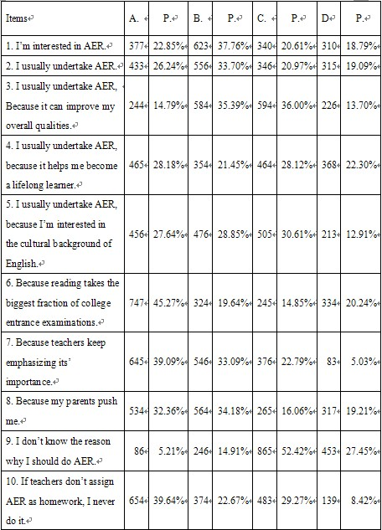

From the table above, we can dig out students’ motivation for AER. From Items1~2, we can see that as freshmen in senior high, 60.61% (22.85%+37.76%) of the investigated student are interested in AER. Meanwhile, almost the same portion of students usually does AER. That is to say, if they are interested in AER, they will undertake AER more often than the students who are not interested. But there are 315 students who seldom do AER and they take up 18.79% in the whole.
Items 3~8 concentrate on different reasons for usually doing AER, most of which can be divided into 3 main reasons: as a goal in a long run (items 3&4), as a profit (items 5~6) and pushed by parents and teachers (items 7&8). From items 3 and 4, half of students realize that AER is good for themselves in a long run by improving their overall qualities and turning them into lifelong learners. Surprisingly, we find that 45.27% students do AER for the reason that reading takes the biggest fraction of college entrance examinations rather than the reason that they are interested in the cultural background of English which supports 27.64% students firmly made their choices. Around one third students did AER because of the pressure from teachers and parents.
From items 9 and 10, it’s not optimistic that around 20% students don’t know the reason why they should do AER, and 39.64% of them choose to ignore AER if teachers don’t assign it as homework! That is to say, part of the students is quite passive when it comes to AER. They have already used to the teacher-oriented teaching method. No wonder that without the “whip” of teachers, they don’t know what to do.
Table 4.1.1-2 (questions 11~19) was designed for the survey on reading goals and schedules. Here are the results.
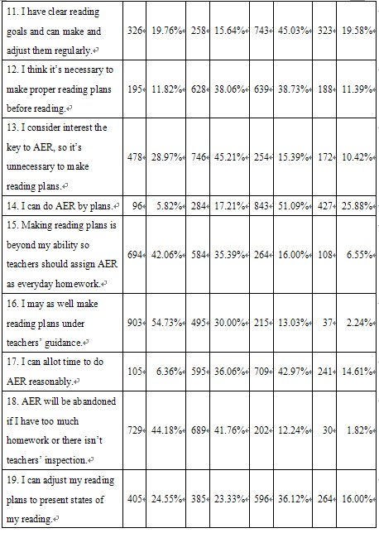
Table 4.1.1-2 (questions 11~19) Reading Goals and Schedules

From item 12, 50.12% (38.73%+11.39%) of the students don’t think it’s necessary to make a plan before reading, yet the rest thinks on the contrary. This tells us that on the necessity of making schedules before reading, students need more guidance to unite a thought. In item 13, the percentage of students considering interest the key to AER is 74.18% (45.21%+28.97%), and in their opinions, with interest, making reading plans is not so necessary. It can be easily found from items 11 and 14; most students don’t have clear reading goals and plans before reading. Even nearly 80% of the students, in item 15, consider making plans should be teachers’ task, and for them, the only task is finishing teachers’ homework, which shows the damage of teacher-centered teaching method. With these thoughts above, it’s no wonder that 85.94% of the students choose abandoning AER if they have too much homework and don’t have teachers’ inspection in item 18. With so many subjects to learn in senior high, how can students learn English well if they don’t have any plans? Fortunately, nearly half of them show the will of adjusting reading time and plans to do AER reasonably, which may not be a good guarantee to do AER but at least show us they are promising in doing AER training.
Table 4.1.1-3 (questions 20 ~40) was designed for the survey on reading strategies and habits. Because these aspects are important to the study so there are 20 items in order to master more initiate situation of students.

Table 4.1.1-3 (questions 20 ~40) Reading Strategies and Habits
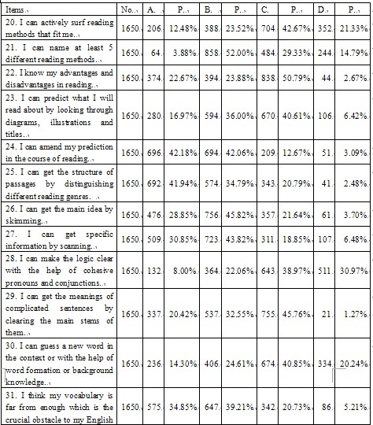
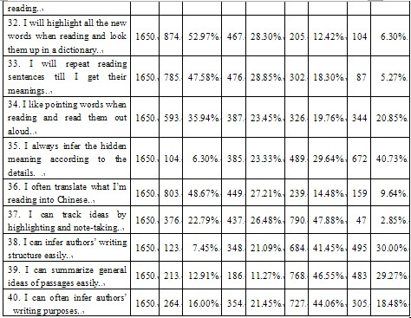
The percentages in items 20 and 21 show that about reading strategies, over half of the students don’t have a clear mind, let alone advantages and disadvantages in reading so 44.55% (23.67%+23.88%) of the students don’t know their advantages and disadvantages as described in item 22. In other items, some specific reading strategies are investigated, such as prediction, skimming, scanning, logic, analysis of the structure of paragraphs and texts, implication, and inference of writing purposes and so on. Among all of these strategies mentioned in table 4.1.1-3, judging the genre of a text, chosen by 76.73% of the students becomes the most common reading strategies used by students. Following it is the second commonly used reading strategy: skimming and scanning, for their percentages are both 74.67% in coincidence presented in item 26 and item 27. 81.27% of the students (from item 31) think vocabulary is the crucial obstacle to their English learning; therefore 52.97% of the investigated students (item 32) always highlight all the new words when reading and look them up in a dictionary. The percentage of the students who always can guess a new word in the context or with the help of word formation or background knowledge takes up only 14.30% as shown in item 30. Compared with strategies mentioned above, students think implication is one of the difficulties when reading, which can be easily found from items 35, 38 and 40.
As for reading habits, we can find the following problems. From items 33 and 34, we can see that in the course of reading, 76.42% of the students always repeat reading sentences again and again, if they can’t get the meaning of these sentences while 59.39% of them tend to point sentences or reading them out loudly when reading. 75.88% of them have the habit of translating what they’re reading into Chinese.
Now let’s put our vision to Table 4.1.1-4, which was cast as a survey on reading results (questions 41~49).

Table 4.1.1-4, (questions 41~49) Reading Results
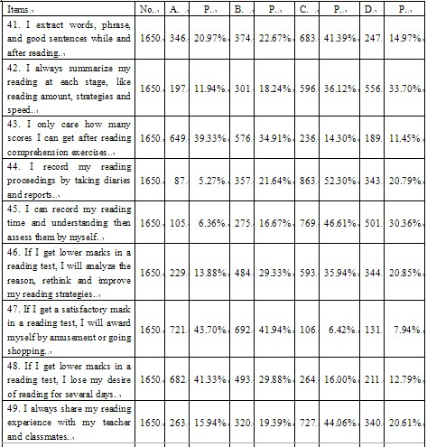
From the table above, students’ choices are various after reading. Frankly speaking, over 70% (39.33%+34.91% in item 43) of the students only care the scores they can get for a reading test rather than analyze the reason, rethink and improve their reading methods (13.88%+29.33% in item 46). Even 71.21% of them will lose their appetite for reading several days if they get lower marks in item 48, on the contrary, if they get a satisfactory mark in a reading test, 85.64% of they choose to award themselves by doing some amusement or going shopping in item 47. What a pity that only 20.97% of the students always extract words, phrases, and good sentences while and after reading! The percentages of students who always summarize their reading at each stage and share their reading experience with teacher and classmates are 11.94% (item 42) and 15.94% (item 49).
The table below presents the choices of reading materials (questions 50~57).

Table 4.1.1-5 (questions 50~57) Choices of Reading Materials
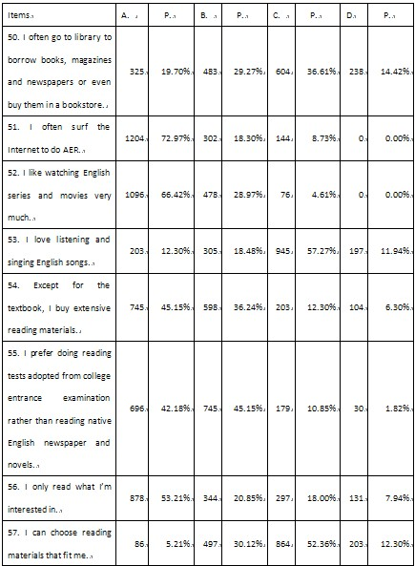
From item 54, 45.15% of the students usually don’t buy extensive reading materials, which don’t mean they are not interested in AER, because 72.97% and 66.42% of the students choose to surf the Internet to do AER and watch English series and movies as presented in items 51 and 52.
Nevertheless, there are 87.33% (42.18%+45.15%) of the students believing that doing reading tests adopted from college entrance examination is more useful than reading native English newspaper and novel. From items 56 and 57, we know that 53.21% of the students usually read what they are interested in while only 5.21% of them can always choose reading materials that fit me.
The last but not the least one, Table 4.1.1-6 tells us the emotions of the learners (questions 58~65).
Table 4.1.1-6 (questions 58~65) Emotions of the Learners
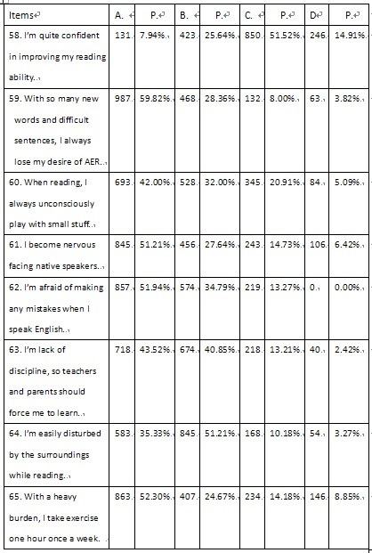

Emotion of learners has a strong effect on the efficiency of learning. From items 58~65, we find that only 7.94% of students are quite confident in improving their reading ability. 59.83% of them are so afraid of new words and long and difficult sentences that they unfortunately lose their interest in AER. 51.94% of them admit that they are afraid of making any mistakes when they speak English, and 51.21% becomes nervous when facing native speakers. In the course of reading, students can hardly focus on what they are reading, and 42% of them always unconsciously play with small stuff, like pens, erasers, rulers…84.37% (43.52%+40.85%) of students believe they are lack of discipline so they hope parents and teachers can help them in that aspect.

Conclusion and Implication
From this survey, we can draw a conclusion that there are some problems in students’ AER in senior one. They are presented as follows:
1. Most students in Senior One do not have a clear motivation and long-lasting interest for AER;
2. Few of students in Senior One has a clear and proper extensive reading plan for improving their English;
3. As for students in Senior One, besides skimming and scanning, they don’t master enough reading strategies to help them face a long reading passage with many new words which becomes an obstacle for them to enjoy the true passion and love of English extensive reading. Therefore it’s hard for them to form a long-lasting reading habit.
4. It’s well known that teenagers are emotional when they make choices and decisions. No wonder that they tend to choose their extensive reading materials according to how much they love it rather than how much they need it.
The second questionnaire (Appendix II) was designed to figure out the reading strategies used by students at the beginning of senior one while reading. It differs from “reading strategies and habits” part in the first questionnaire. The part of reading strategies and habits in the first questionnaire deals with the general situation while the second questionnaire emphasized strategies themselves more by naming these strategies. By doing so, strategies were registered in students’ minds from the beginning of the experiment. The third (Appendix IV) was used to investigate the process of AER training and help students assess their training in the experimental class. To help students and the author get accurate information, all these three questionnaires are designed in Chinese.
Interviews were applied randomly between the author and students in the experimental class during the process of the experiment and at the end of the experiment to gain the first-hand data.
A pretest (Appendix III) was given to both the control and the experimental classes before the experiment to know the foundation of their competence in English reading. Then the experimental class started to receive the AER teaching and training, which lasted two semesters; meanwhile the control class received the traditional teaching method. A mid-test (Appendix V) was given to both the control and experimental class at the end of the first semester and a posttest (Appendix VI) was given at the end of the second semester to gain further information about AER.

4. 1. 2 Data Analysis of the protest, mid-test and posttest

4. 1. 2. 1 Data of the protest
The tested class
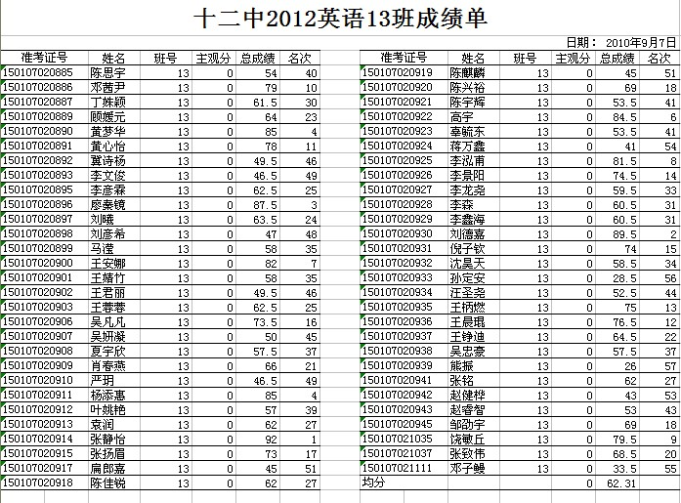
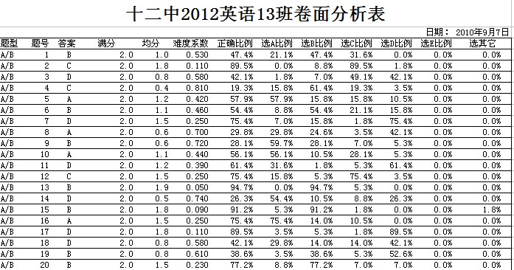

 | No. | Ratio:
Excellent： | 8 | 12.5%
Good： | 10 | 15.6%
Pass： | 26 | 40.6%
Others： | 20 | 31.25%

The control class


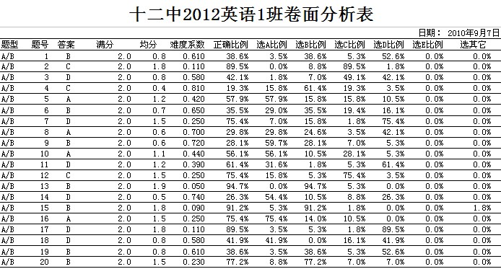

 | No. | Ratio
Excellent： | 7 | 10.93%
Good： | 11 | 17.18%
Pass： | 24 | 37.5%
Others： | 24 | 37.5%

From the figures, we know basically, two classes’ students have similar English competence, and their reading competence is low. Among the 20 items，whose full marks are 40, 8 students are excellent, ratio is 12.5%；20 students didn’t pass which take up 31.25%. Students usually make the most mistakes in the flowing items and strategies:
Item | 1 | 3 | 4 | 6 | 8 | 9 | 10 | 14 | 18 | 19
strategies | Specific  details | Details  judges | Purpose  of writing | Infer | Purpose | Guess | infer | details | Guess | purpose
And from the averages and analyses of the test paper, we can safely make a conclusion that, at the beginning of the experiment, the control class and the tested class almost have an equal reading competence overall.

4. 1. 2. 2 The instructions and strategies on AER applied in the experimental class (the first semester)
Since the third week of September 2010, the students in Class 13 (the experimental class) were trained under the instructions and strategies on AER whereas Class 1 (the control class) was trained in the traditional method.
Here are the detailed planning and methods applied in the experimental class, Class 13.
Adaptive period (around 2 months): unite a thought and form consensus.
The main goal of this period is to arouse students’ independent consciousness. Students shall transfer from being guided to being aided by the teacher. Because most of the students in Senior One have got used to the teacher-centered teaching practice, they will feel confused and lost their sense of directions if suddenly exposed to a completely new approach. At the same time, they need some time to get to know an unfamiliar campus and teaching strategies of a new teacher in Senior One.
Step one: define the learning goals in English in Senior High.
Different English learning tasks fall in different periods in Senior High, and reading various English materials to increase their input thus to lay a firm foundation for further English learning shall be the main task in Senior One. Therefore, students were guided to read National English Curriculum Standards for Senior Middle Schools to know their tasks in English learning in Senior High. Then, according to their seats, students in Class 13 were divided into 10 groups to discuss how to finish all these tasks. The answers vary. Some believed that to get a higher starting position, we should try to finish all of them in the first two years in Senior High while some thought that it’s a problem belonging to English teachers and students should only follow the teachers orders. Even some of them mentioned that they would prefer doing more exercises e.g. the reading tests in the College Entrance Examinations! Their thoughts really shocked me. So I decided to help students transfer their opinion and help them love extensive reading.
Step two: guide students to form a series of good learning habits.
Develop the habit of listening carefully in class to improve in-class efficiency.
The teacher shall help students to understand the contents of teaching. Students should understand the teacher’s directions, including his/her handwriting, items of English classes and shall also be helped to know the process of English learning. Only when they can follow what the teacher is talking, can they start enjoy the magic of English language itself and then taste the joy of achievements.
Develop the habit of taking careful notes.
In this way, students can trail the contents any time. Their notebooks will be checked every week and graded by A plus to D minus. Each grade equals some scores, for example, A plus means the student can get 5 points; D minus means he/she will lose 10 points.
Develop the habit of asking questions.
Students are encouraged to ask 1~2 questions every day, which can earn 1 score for them. By doing so, students are pushed to think over what they are learning or progressing in AER.
Develop the habit of sharing their opinions.
They are also forced to do presentation, pair work and group discussion on what they’re reading. And each time, everyone of them has to take notes more or less and these notes will be checked and graded after each activity.
Then, on each Saturday, all the scores one student can gain will be accumulated, printed and hung up to let all the class know. And each month, these scores will be delivered to their parents to let them know students’ performance in AER.
Step three: group students again and build up a class library.
First of all, students were divided into 10 groups by their wish and one student will be chosen as the group leader. Secondly, the teacher shall give an outline for learning prior to the student’s practice. Some meaningful and interesting reading materials were appointed as must-be-read, such as The Chicken Soup for the Soul, Bookworm series, The 21st Century and some adaptations of famous English novels. Thirdly, every student in Class 13 should donate one copy of the appointed materials above, or what they wanted to recommend to their classmates, of course, in English In this way, we set up an English library together.
Step four: Brainstorming
In this step, firstly, students in charge of English registered all the books. Every week the group leader borrowed enough extensive reading materials for group members to read, and every student should write a reading note. Secondly, the teacher should check their reading notes every week and gave comments immediately to encourage students loving reading. Thirdly, I would pick out the best five copies and shared them with all the students. The chances of making comments on these copies would also be given to the whole class. That is to say, students’ English reading and expression ability could be trained at the same time.
Step five: the learning of reading strategies
Meanwhile, in the process of high school English intensive reading learning students should be taught efficient reading strategies to help them improve their reading efficiency to establish learning initiatives. Besides skimming and scanning, the following should be covered: form a good reading habit, for example, read silently by minds not by hands or rulers; guess new words meaning in the context; word formation; prediction by looking through diagrams, illustrations and titles; make the logic clear etc. At the end of each class, students will be guided to make a summary about what reading strategies they have used or learnt in this class and take careful notes.
Step six: the support from parents
Education is not only an event happening in school but also an event existing at home. So, make friends with students’ parents. They care about their children’s future therefore a common email box, a micro blog or anyway that can connect the teacher and parents are good choices to improve the friendship among parents and teachers. Tell them the final goals of English learning and the importance of AER in Senior One. They would be very happy to “spy” students extensive reading at home.
Semi-self-decided period (around 2 months)
With the preparation in adaptive period, students have developed certain capacity of learning, teachers shall help them in determining the materials, content and progress of reading and students shall keep notes properly. At this time, more activities could be given to students to keep their interest in AER, such as class presentations, reading salons, hand writing English newspapers, practical reading reports, English Corners, English lectures given by foreign teachers …
Hand writing English newspapers:

At the beginning, the theme and the form of each activity will be appointed by the teacher, and the senior students whose English is fluent will stay close to the teacher to put the teacher’s thoughts into practice. And the group leaders should keep their members organized and join these activities actively. Meanwhile, the group leaders should find out one student in their group as the secretary to keep notes of groups’ process and collect materials and results of these activities.
With students’ ability increased, of course, students can put forward more activities if possible. At the end of this period, a mid-test would be given to both classes to test how far each class had moved forward, the figures of which would be analyzed carefully in the next session.

4. 1. 2. 3 Data of the mid-test and the interview
In Dec. 2010, the mid-test was given to both the experimental and control classes to collect relevant data during the course and did proper adjustments to keep the experiment carried out smoothly, if necessary.
The figures of the mid-test:
The control class

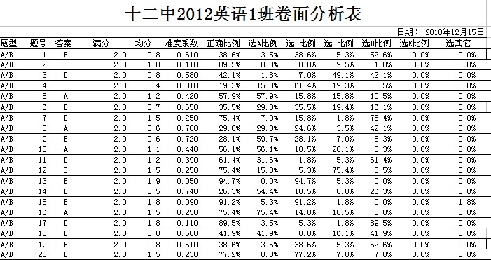

The tested class
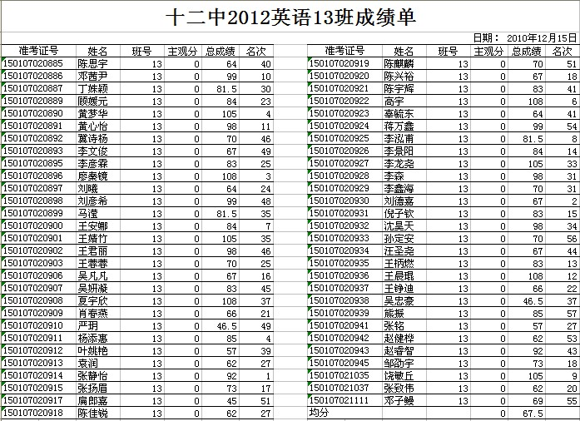
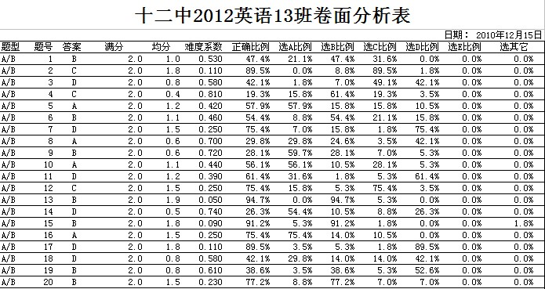
From the above data, it can be easily found out that the experimental class has a high average score (67.5) compared with the control class (64.54).
Data Analysis of the interview
Moreover, an interview was carried out to help students in the experimental class evaluate and assess their changes on AER. (See Appendix IV)
From the interview, we know that most students in the experimental class became interested in AER for it brought happy to most of them and broaden their horizon. And by doing AER, they know more reading approach and strategies, such as, 80% of them can guess a new word in the context or with the help of word formation or background knowledge; 70% of them will highlight all the new words when reading and look them up in a dictionary; 55% of them always infer the hidden meaning according to the details. 45% of them can infer authors’ writing structure easily.

4. 1. 2. 4 The instructions and strategies on AER applied in the experimental class (the second semester)
Self-decided period (around 4 months)
In this period, students will play the leading role in AER activities, especially the students in charge of English and the group leaders. Each group is a small reading club. They can organize reading activities, determine the highlights and key points, seek for answers in reference books, discuss and argue in groups and supplement and summarize by themselves. When they discovered some high quality reading materials, they can recommend to the whole class, even they can apply for an English class to share the worthwhile reading material with all classmates.
In this period, it appears that students are the controller of AER, but the guidance from teachers is also crucial. As for teachers, the main task in this period is to help students learn how to assess themselves properly. Establishing an all-round evaluation system is not an easy task just like Rome was not built in one day.
The following are some of the self-assessments forms applied to assess their AER by students.
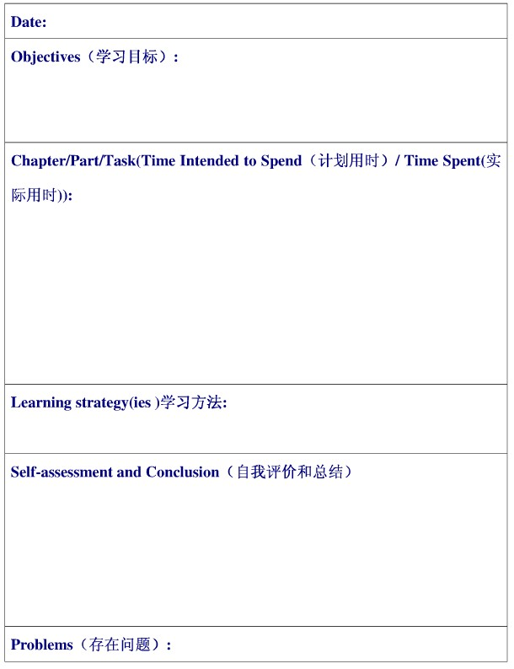

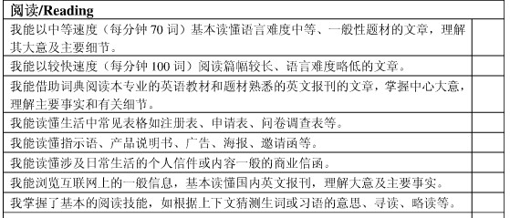
Besides developing students’ self-assessment ability, it’s also important to teach students how to analyze and comment others’ reading reports. They can exchange their reading reports and give comments by group.
Last but not the least, making a personal reading schedule is also an excellent way to make sure AER tasks to be finished and it will be a reminder of readers’ hardworking, which will be of help when it comes to the perseverance of AER.

4. 1. 2. 5 Data of the posttest
In Jul. 2011, the end of the second semester, the posttest was implemented to both experimental and control classes and the same interview was given to collect deep-seated information on AER.
The controlled class
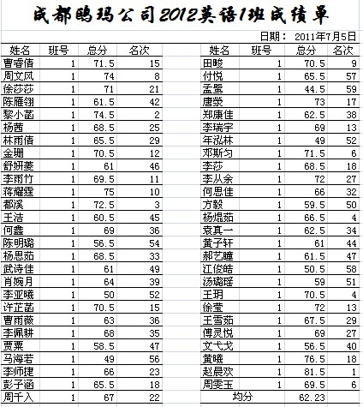
 | No. | Ratio
Excellent： | 12 | 18.6%
Good： | 34 | 54.3%
Pass： | 14 | 10.3%
Others： | 4 | 7.8%

The tested class
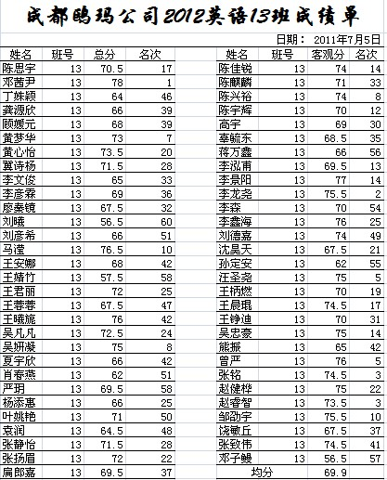

 | No. | Ratio
Excellent： | 30 | 50%
Good： | 22 | 38.3%
Pass： | 6 | 10%
Others： | 2 | 2.7%

From the results of the posttest, we surprisingly found out the difference between the tested class and the control class becomes very large. The average score of the tested class is almost 8 points higher than that of the control class in the posttest!

4. 2 Major findings
Compared with the reading scores in pretest, the reading scores of students in the tested class are obviously higher than those in the control class. AER did improve students reading competence, which will be detailedly discussed in Chapter 5.

Chapter Five

Pedagogical Implications and Suggestions

The following pedagogical implications can be made through this study.

5. 1 Pedagogical Implications

5. 1. 1 Learner-centered teaching model
During this experiment, the author constantly centers on the students by accurately analyzing the students’ conditions at all phases, believing in their capacities and appointing 8 to 10 course representatives to exemplify among others.

5. 1. 2 Enlarging students’ vocabulary
Rome cannot be built in one day, so are the vocabulary of students’. New words can be found in every passage. So, encourage students to open their heart to new words and try to guess the meaning of them in the context. While reading, underline the new words that cannot be guessed out in the context and when finish reading, look up them in a English-English dictionary then take careful notes for their pronunciation, English meanings and even a simple scene to recite them. Little by little, students will happily find that their vocabulary is enlarged, and they fear English reading no more.

5. 1. 3 Enriching students’ background knowledge of English
It’s not uncommon that even students know they should keep reading, while they just can’t understand what they are reading! Because it beyond their background knowledge. It’s just like you can’t count on a kindergarten to understand Hawkin’ Big Bang and the Brief History of Time!
As we know, teenagers will make decisions on what to read by their own preference, teachers can assign some special “assignments” to overwhelm it. For example, teachers can set up a forum with fixed themes about environment, economy, politics … and write down all of them into different pieces of paper then put them into a box. Ask groups of students to draw out one, and make a presentation accordingly. Or hold a debate just like Model United Nations.

5. 1. 4 Stimulating students’ motivation and interest in AER
As illustrated in Pedagogical Psychology that interests, being the inner motivations for study, are the most active among all stimulants, and pointed out by the renowned educator Bruner that it is the interests upon the study subject that best stimulate one’s desire for knowledge, our emphasis is thus placed onto raising students’ motivations and interests toward AER in their extra-curriculum reading.
Since students’ motivations and interests upon AER count largely on the fields and content of the reading materials, importance shall be attached to choosing those into the students’ appetite and within the students’ intellectual reach. Teachers, while creating for the students English reading opportunities and environment as far as possible, shall assigned to students reading materials of appropriate difficult and into their interests, such as humorous stories. Furthermore, another wise trial shall be hosting ex-curriculum activities such as a reading contest. Students are also allowed to select reading materials at will at preliminary phase, but shall be guided into a wider range of fields at the second their interests have been brought out. In a word, teachers shall select various extensive reading materials in a bid to foster the students' interests upon reading.

5. 1. 5 Integrating AER resources
To keep abreast with the times and find more interests in reading, we have to integrate materials involved in varied fields. However, students at the first grade in high school may not be good choosers, who are in urgent need of guidance from teachers. First and foremost, songs, videos and movie clips shall be added to the class to arouse interests among students, and fascinate them to further their exploration and understanding after class. As they become more interested and capable, they can be guided to material such as English newspaper, magazines, even some masterpieces to help them taste the beauty of English language.

5. 1. 6 Strengthening the instruction of reading strategies
Proper reading strategies are to students what wings are to little birds. Mastering more reading strategies can help fly high in the sky of English learning. In the AER training, students in the control class are always reminded of judging and applying proper reading strategies and every week there will be one class used to train them to master reading strategies.

5. 1. 7 Helping students make a proper schedule, monitoring it and assessing the proceedings
At the beginning of each semester, students in the control class were asked to make their own schedule, including what you want to read in this semester, how to finish it, what instruments they would use to finish it etc. And at the end of each month in this semester, they were asked to review how far they had gone according to their schedule, and they could revise it if the schedule is not good for themselves. The students were divided in group of 6, one of who was the leader. It’s the group leader’s responsibility to check whether the group members finished their reading schedule. Every month, the leader would be changed to make sure every student get the chance to help others and improve their own manage ability. If students could not finish their schedule on time, they would have a immediate conversation with the teacher to adjust their reading plan accordingly.
In this way, students can learn how to make a proper schedule, monitoring it and assessing the proceedings

5. 2 Suggestions
The following suggestions can be gained through this study as:
* The independent consciousness shall be aroused among students.
* In the process of high school teaching, teaching and learning are mutually
dependant, with teaching serving as the object.
* Students shall be taught step by step and in plans to establish their learning initiatives;
* Adaptive period. Students shall transfer from being guided to being aided by the teacher. Teacher shall give an outline for learning prior to the student’s practice.
* Semi-self-decided period. Provided students have developed certain capacity of learning, teachers shall join them in determining the materials, content and progress of the reading, and student shall keep notes properly.
* Self-decided period. At this period, students can determine the highlights and key points, seek for answers in reference books, discuss and argue in groups in class, and supplement and summarize by themselves.
* To develop the habit of listening carefully in class and improve in-class efficiency
* To enhance guidance of learning methods
* Summarize, compare, inspire, cooperate in learning and expand imagination
* To reinforce guidance in students’ learning psychology
* To promote students’ appraisal upon their automatic learning
* To establish an all-round evaluation system
* Appraisal of knowledge combined with emotion and attitude
* Inspiration first, mutual evaluation
* To perform self-evaluation with “reflection cognition” method

Conclusion

Till now we can safely draw a conclusion that AER do has an assistant role on extensive reading in Senior One. The author found some efficient approaches to transform the passive and knowledge-based English-teaching of reading to a more meta-cognitive and interesting process and experience to students, which in return improve students’ performance in English-learning in reading. Thus, students can taste the wonderful flavor of learning and build the confidence of being a lifelong learner and a qualified global citizen.
But there are also some limitations of this study. It’s a pity that this study has limited time which lasted only one year and with only 124 inadequate participants.
For anyone who is interested in AER, and wants to so a further study, here are some suggestions:
- Make friends with students and parents. The more you respect them, the more possibility that you can influence them with AER.
- Keep careful track of students’ every step and according to their desires to adjust parts of your plans.
- If possible, invite more teachers and students join in this study.
- Keep contact with the students studying AER to figure out how much they will be influenced by AER.

Bibliography

English Works
Anderson, N. J.1999，Exploring Second Language: Issues and Strategies. Heinle & Heinle: Heinle & Heinle Publishers:9.
Booton, P. and Benson,P.1996. Self-access: Classification and Retrieval. Manchester: British Council.
H. Dougla Brown,M. Teaching by Principles: An Interactive Approach to Language Pedagogy.Beijing.Foreign Language Teaching and Research Press.2001.
Holmes,J.L. and Ramos, R.1991.Talking about learning:establishing a framework for discussing and changing learning processes.
Jacques Delors,R. UNESCO of the International Commission on Education for the Twenty-first Century. France.1996.
Jiang Yunju.2006. A Study of Effectiveness of Reading Strategies Training in Senior School.Fuzhou:Unpublished MA dissertation, Fujian Normal School.
Kenny,C.1993. For more autonomy. System 21(4)431-42.
LV. Zhongshe.2003. Readability in Reading Materials Selection and Course Book Design for College English in China. Beijing: World Knowledge Press.
Moore,C.1992.Self-Access: Appropriate Technology. Manchester: British Council.
Nation,I.S.P.Teaching and Learning Vocabulary. Cambridge: Cambrige University Press.2004.
National English Curriculum Standards.普通高中英语课程标准（实用 2003），人民教育出版社，2003.
Nuttall,Christine.2002.Teaching Reading Skills in a Foreign Language. Shanghai Foreign Language Eduacation Press.
Sheerin,S.1991.Self-access: State-of-the-art-article.Languge Teaching.
Wenden A. Leaner Strategies for Learner Autonomy. Great Britain: Prentice Hall,1998.
William Grabe & Fredricka L .S.2005, Teaching and Research Reading. Beijing: Foreign Language Teaching and Research Press: 9, 16, 38.

中文文献
戴玥赟.外语学习中阅读焦虑感与阅读元认知策略的相关性研究[D].长春：吉林大学，2007.
董艳萍.心理语言学与外语教学.北京：外语教学与研究出版社, 2005
黄珊.大学英语阅读教学中的交互模式应用研究[D].长沙：湖南师范大学，2001.
李玉华.非英语专业大学生英语阅读策略的使用情况研究[D].南昌：江西师范大学，2007.
梁晓菊.提高英语阅读能力的策略（英文）[J].科技信息.2009,35(13):13-15.
实验后测试题, 2011年四川省英语高考阅读题, 搜狐教育, 2011, 06,08, URL=<http://learning.sohu.com/20110608/n309648785_4.shtml>
实验前测试题, 2009年四川省英语高考阅读试题, 高考网, URL=<http://www.gaokao.com/e/20100513/4bebcc9a97bc0.shtml>
实验中测试题, 2010年四川省英语高考阅读题, 百度文库, 2010,10,21,WENJUNCN,URL=<http://wenku.baidu.com/view/0e4caa661ed9ad51f01df27e.html>
舒白梅.编.现代外语教育学.上海：上海外语教育出版社, 2005.
王文娟.高职英语专业阅读教学元认知策略培训研究[D].济南：山东师范大学，2011.
王星远.元认知策略培训对高职英语专业学生阅读能力和元认知意识的影响[D].上海:上海外国语大学，2008.
王秀香.高中英语教师角色转换[D].新乡：河南师范大学，2005.
张必隐.2004.阅读心理学[M].北京：北京师范大学出版社：2,3,4，28,34,36,215.
张向阳.阅读策略教学对大学英语英语阅读理解的效果[D].贵阳：贵州大学，2006.

Acknowledgements

First of all, I would like to express my appreciation to all the teachers at School of Foreign Languages at Sichuan Normal University, whose instructions and guidance have made my three years at the university a truly rewarding experience.
Words fail me when I try to express my heartfelt thanks to my supervisor, Professor Yin Shiyin, for all his inspiring ideas and kind help throughout the process of my graduate thesis writing. Without his helpful suggestions, his clear guidance and his patient corrections, the accomplishment of this graduation paper would have been impossible.
In particular, I wish to express my sincere thanks to my family. They gave great support and help to me, so I can spare my energy and time to only focus on the thesis. Without their support, I can’t finish this thesis! Thank you!

Appendix I

高一学生英语自主阅读情况问卷调查表
亲爱的同学：
您好！欢迎大家就读成都12中！为了了解您的英语阅读基础和水平，便于老师在高一有针对性的进行英语阅读教学，特设计本表。请您根据自己的实际情况，认真思考后选出符合自己实际情况的选项，并将其转涂到机读卡上。
本调查表仅作为老师了解您现在的英语阅读基础和水平，并不因此评定您的学习成绩，非常感谢您的合作！
A. =大部分符合我的实际情况
B. =有点符合我的实际情况
C. =有点不符合我的实际情况
D. =大部分不符合我的实际情况
第一部分：阅读动机
1. | 我对英语课外自主阅读很感兴趣。 | A. | B. C. | D.
2. | 我平常经常积极进行英语课外自主阅读。 | A. | B. C. | D.
3. | 我积极进行英语课外自主阅读是因为它可以提高我的自身综合素质。 | A. | B. C. | D.
4. | 我积极进行英语课外自主阅读是因为它可以帮助我成为终生学习者。 | A. | B. C. | D.
5. | 我积极进行英语课外自主阅读是因为我对英语文化背景感兴趣。 | A. | B. C. | D.
6. | 我积极进行英语课外自主阅读是因为高考题中阅读分值最大。 | A. | B. C. | D.
7. | 我进行英语课外自主阅读是因为老师不断强调阅读的重要性。 | A. | B. C. | D.
8. | 我进行英语课外自主阅读是因为父母的督促。 | A. | B. C. | D.
9. | 我不知道为什么要进行英语课外自主阅读。 | A. | B. C. | D.
10. | 如果老师不布置，我从不进行英语课外自主阅读。 | A. | B. C. | D.
第二部分：阅读目标和计划
11. | 我有明确的阅读目标，并有规律的合理制定和调整阅读目标。 | A. | B. C. | D.
12. | 我认为根据阅读目标制定切实可行的阅读计划很有必要。 | A. | B. C. | D.
13. | 我认为课外阅读关键在于兴趣，随意读就是，不需要目标和计划。 | A. | B. C. | D.
14. | 我总是能按计划进行英语课外自主阅读。 | A. | B. C. | D.
15. | 我制定不来计划，老师应该把课外阅读布置成全班每天的家庭作业。 | A. | B. C. | D.
16. | 老师可以和我一起设计适合我的英语课外阅读计划。 | A. | B. C. | D.
17. | 我每天能按照计划保证英语课外自主阅读的时间。 | A. | B. C. | D.
18. | 只要老师不检查，作业少就读，作业多就不进行课外阅读。 | A. | B. C. | D.
19. | 我能根据自己当前的阅读情况来调整阅读计划。 | A. | B. C. | D.
第三部分：阅读过程和习惯
20. | 我能积极探索适合自己的英语阅读方法。 | A. | B. C. | D.
21. | 我现在能说出五种以上的阅读方法。 | A. | B. C. | D.
22. | 我了解自己在英语阅读方面的优势和劣势。 | A. | B. C. | D.
23. | 阅读前，我能根据图表，插图和文章标题等预测文章内容。 | A. | B. C. | D.
24. | 阅读时，我能根据所读文章内容修正先前的预测。 | A. | B. C. | D.
25. | 我能识别文章体裁，并根据体裁理解文章结构。 | A. | B. C. | D.
26. | 我能通过略读，快速掌握文章大意。 | A. | B. C. | D.
27. | 我能通过查读，迅速找到特别的细节信息。 | A. | B. C. | D.
28. | 我能利用表示因果、转折、递进等连词理清文章逻辑关系。 | A. | B. C. | D.
29. | 遇到长难句时，我能准确通过找出句子主干来理解句意。 | A. | B. C. | D.
30. | 遇到生词时，我能根据上下文，常识或者构词法，猜出生词意思。 | A. | B. C. | D.
31. | 我觉得词汇量不足是阻碍我英语阅读进步的关键原因。 | A. | B. C. | D.
32. | 我觉得阅读中所有的生单词都要勾出来，查字典。 | A. | B. C. | D.
33. | 阅读时，读不懂我就一遍一遍的反复读。 | A. | B. C. | D.
34. | 阅读时，我要用手或笔指着单词读，或者是要读出声来。 | A. | B. C. | D.
35. | 我能根据上下文对文章细节进行推理判断，准确理解隐含之意。 | A. | B. C. | D.
36. | 在阅读理解时，我老是要先翻译成为中文。 | A. | B. C. | D.
37. | 我能通过划线或做笔记的方式整合信息，来把握文章思路。 | A. | B. C. | D.
38. | 阅读时，我能够理清文章或是段落的写作思路。 | A. | B. C. | D.
39. | 阅读时，我能归纳出段落大意。 | A. | B. C. | D.
40. | 我能通过上下文，推断出作者的写作意图。 | A. | B. C. | D.
第四部分：阅读结果
41. | 我喜欢讲优美的句子勾画出来，进行摘抄和总结。 | A. | B. C. | D.
42. | 我总是对每个阶段的阅读情况（阅读量、方法、速度等）进行总结。 | A. | B. C. | D.
43. | 每次做完阅读题，我只对答案，看自己错了几道题。 | A. | B. C. | D.
44. | 我通过记日记、写读书报告等方式总结记录自己的学习进程。 | A. | B. C. | D.
45. | 我会总结自己的阅读时间并尝试评价自己对文章的理解程度。 | A. | B. C. | D.
46. | 当阅读错误率较高时，我会分析原因，反思并改善阅读方法和策略。 | A. | B. C. | D.
47. | 当取得较好的阅读测试分数时，我通过娱乐、购物等方式奖励自己。 | A. | B. C. | D.
48. | 当取得不好的阅读测试分数时，我就不想再进行课外自主阅读了。 | A. | B. C. | D.
49. | 我常与老师和同学们交流阅读的心得体会。 | A. | B. C. | D.
第五部分：阅读材料
50. | 我常到图书馆借或者是到书店买英语相关的报刊，杂志或书籍。 | A. | B. C. | D.
51. | 我常利用网络进行英语课外阅读。 | A. | B. C. | D.
52. | 我喜欢看英语电视剧和电影。 | A. | B. C. | D.
53. | 我喜欢听英语歌曲，并学唱英语歌曲。 | A. | B. C. | D.
54. | 除课本外，我自己购买了不带英语题的英语课外报刊等泛读资料。 | A. | B. C. | D.
55. | 我觉得做英语高考阅读题比读英语报刊和小说等对阅读的帮助更大。 | A. | B. C. | D.
56. | 我只读自己感兴趣的英语阅读材料。 | A. | B. C. | D.
57. | 我能根据自己的水平选择合适自己的阅读材料。 | A. | B. C. | D.
第六部分：学习情绪
58. | 对于提高自己的英语阅读能力，我很有信心。 | A. | B. C. | D.
59. | 当阅读材料中有较多生词和长难句，我比较焦虑，就不想读了。 | A. | B. C. | D.
60. | 阅读时，我喜欢不自觉的转笔或者是耍东西。 | A. | B. C. | D.
61. | 遇到说来自于说英语国家的人，我就紧张，不敢说话。 | A. | B. C. | D.
62. | 凡是要用英语表达的情境，我都紧张，怕出错。 | A. | B. C. | D.
63. | 我自觉性较差，需要老师和家长不断的督促。 | A. | B. C. | D.
64. | 我学习时，容易受到外界事物的干扰。 | A. | B. C. | D.
65. | 学习压力太大，我每周锻炼的时间总计不足一小时。 | A. | B. C. | D.
Appendix II

高一学生英语阅读策略调查表
亲爱的同学：
您好！
为了进一步全面了解您的英语阅读基础、阅读习惯和方法，加强师生的有效配合，从而最终使你们更好地学好高中英语，特进行本次问卷调查。本问卷仅作科学研究使用，不会作为评价你英语阅读好坏的依据，因此无须有任何顾虑，请根据自己的实际想法和做法如实回答。填写时请不要与别人讨论，谢谢你的合作！

序号 |  | 阅读策略名称 | 注解
1 | 带目的阅读 |  | 我在阅读时带有阅读目的。
 | A.总是如此 B.有时候这样 C.几乎没有
2 | 预览 |  | 我会为了更好的了解阅读主题和大意而预习课文。
 | A.总是如此 B.有时候这样 C.几乎没有
3 | 略读 |  | 我会用快速浏览全文，来掌握文章大意。
 | A.总是如此 B.有时候这样 C.几乎没有
4 | 查读 |  | 我会用快速浏览全文，来寻找文章中的细节。
 | A.总是如此 B.有时候这样 C.几乎没有
5 | 群读 |  | 在读的过程中，会将几个词按意思当成一个整体来看。
 | A.总是如此 B.有时候这样 C.几乎没有
6 | 避免坏习惯 |  | 会放弃坏的阅读习惯：指读、默读等。
 | A.总是如此 B.有时候这样 C.几乎没有
7 | 预测 |  | 我会预测将要读到的内容。
 | A.总是如此 B.有时候这样 C.几乎没有
8 | 积极思考 |  | 在读的过程中，我会积极地问问题并尝试解决问题。
 | A.总是如此 B.有时候这样 C.几乎没有
9 | 推断 |  | 我会根据上下文，推测没有直接在文中陈述的观点。
 | A.总是如此 B.有时候这样 C.几乎没有
10 | 识别题材 |  | 我能提炼出所读文章的结构。
 | A.总是如此 B.有时候这样 C.几乎没有
11 | 理清结构 |  | 我能提炼出所读段落的结构。
 | A.总是如此 B.有时候这样 C.几乎没有
12 | 判断句子结构 |  | 在复杂的句子中，我能判断出句子成分。
 | A.总是如此 B.有时候这样 C.几乎没有
13 | 连贯理解 |  | 我能辨别出连接代词和连词。
 | A.总是如此 B.有时候这样 C.几乎没有
14 | 猜测词义 |  | 我能根据上下文猜出生单词的意思。
 | A.总是如此 B.有时候这样 C.几乎没有
15 | 识别修辞 |  | 我能读懂比喻性语言和隐喻。
 | A.总是如此 B.有时候这样 C.几乎没有
16 | 背景知识 |  | 我能懂得文章相关的背景知识。
 | A.总是如此 B.有时候这样 C.几乎没有
17 | 判断写作意图 |  | 我能推断出作者的写作意图。
 | A.总是如此 B.有时候这样 C.几乎没有
18 | 信息整合 |  | 我能通过强调和记笔记等方式来记录文章的观点。
 | A.总是如此 B.有时候这样 C.几乎没有
19 | 及时总结 |  | 我总是复习已经学到过的知识。
 | A.总是如此 B.有时候这样 C.几乎没有
20 | 复述课文 |  | 我能用自己的话复述学过的课文。
 | A.总是如此 B.有时候这样 C.几乎没有

Appendix III A pretest 实验前测英语阅读试题
引用自2009年四川省高考英语阅读题

Appendix IV
高一学生英语课外自主阅读问卷调查表
亲爱的同学：
您好！通过一学期的英语课外自主阅读（AER）相关的学习，为了帮助你进行反思和总结，并让老师更准确的了解你的英语课外自主阅读学习状况，请您根据自己的实际情况，认真的独立完成下表。本问卷调查感并不作为衡量您本期英语水平用，答案没有对错之分。感谢您的配合！

1. 你对英语课外自主阅读（AER）感兴趣吗？为什么？
2. 通过本学期的AER学习，你学到了什么阅读方法和策略？
3. 你能根据现在自己的英语水平，选择适合自己的英语课外自主阅读材料吗？请举例说明。
4. 通过本学期的AER学习，在英语阅读策略方面，你的收获是什么？请举例说明。
5. 你认为AER能提高你的英语阅读能力，英语综合语言能力和英语语言流畅度吗？请举例说明。
Appendix V A mid test英语中测阅读试题
引用自2010年四川省高考英语阅读题

Appendix VI a posttest 实验后测英语阅读试题
引用自2011年四川省高考英语阅读题

